Cooking Steel Cut Oats in the Instant Pot
Are Steel Cut Oats Better for you than Rolled Oats?
Steel cut oats and rolled oats both come from the same whole grain cereal, so they have similar nutrition content and really only differ in their processing. Rolled oats are steamed, then rolled to produce their signature flat look and quick-cooking texture. Because they are tender and cook quickly, they are ideal for adding to baked goods.
Steel cut oats, on the other hand, are less processed. To make steel cut oats, the oat groat is sliced with a steel blade to create more of a chopped, rice-like grain that is chewier in texture and takes longer to cook.
Though, the cooking time isn’t a problem when you have an Instant Pot. Just press a button and walk away until it’s ready! I love not having to babysit my oats on the stove top, or worrying about them burning on the bottom.
The key to cooking perfect steel cut oats in the Instant Pot is allowing the pressure to naturally release after the initial 4 minute cooking cycle. While the pressure releases, the oats absorb the water without burning on the bottom of the pot. This prevents sticking and allows the oats to become perfectly tender. You just have to be patient!
While a 4-minute cook time sounds ridiculously fast for a bowl of steel cut oats, the entire process takes closer to 30 minutes when you take into account the 5 minutes for the Instant Pot to come to pressure, 4 minutes for the cooking cycle, and then about 20 minutes for the pressure to naturally release. This isn’t any longer of a process than cooking them on a stove top, but it’s also not significantly faster.
The Benefit of Using an Instant Pot
The real benefit of using the electric pressure cooker, if you ask me, is the hands-off approach. Instead of waiting over the stove for the water to come to a boil, then adding the lid, lowering the temperature, and checking on the oats to check for tenderness, you can truly “set it and forget it” with the Instant Pot.
Just press a button and walk away until you’re ready to eat!
If you forget to check on the oats for 10 minutes, they won’t burn, and in fact, the Instant Pot will keep them warm until you’re ready to eat. I love this thing, and I hope you’ll love these easy steel cut oats just as much, too.
Are Steel Cut Oats Gluten-Free?
Oats are naturally gluten-free, but they are often processed in facilities that process gluten-containing grains, and therefore you run the risk of cross-contamination. If you need to stay gluten-free, be sure to look for oats with a certified gluten-free label on the package.
Ingredients
- 2 cups steel cut oats (certified gluten-free, if necessary)
- 4 to 5 cups water

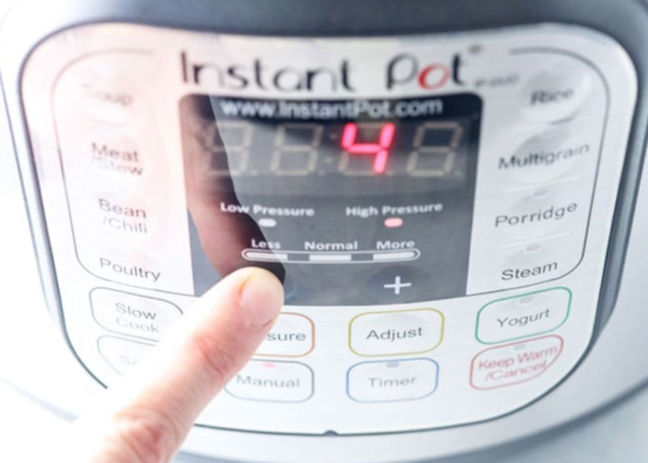
Instructions
Combine the steel cut oats and water in the bowl of your Instant Pot and give them a stir. Use 4 cups of water for thicker oats, or 5 cups of water for more of a porridge-like texture. Cover with the lid and make sure you turn the vent at the top to "sealing."
Press the manual button and then lower the time to 4 minutes on high pressure. The cooker will automatically start.
After the Instant Pot beeps, allow the pressure to naturally release for 20 minutes. (The timer on the Instant Pot will remain on after the cooking cycle to let you know how long it's been kept warm, unless you press the off button. I like to keep it on for the timer function.)
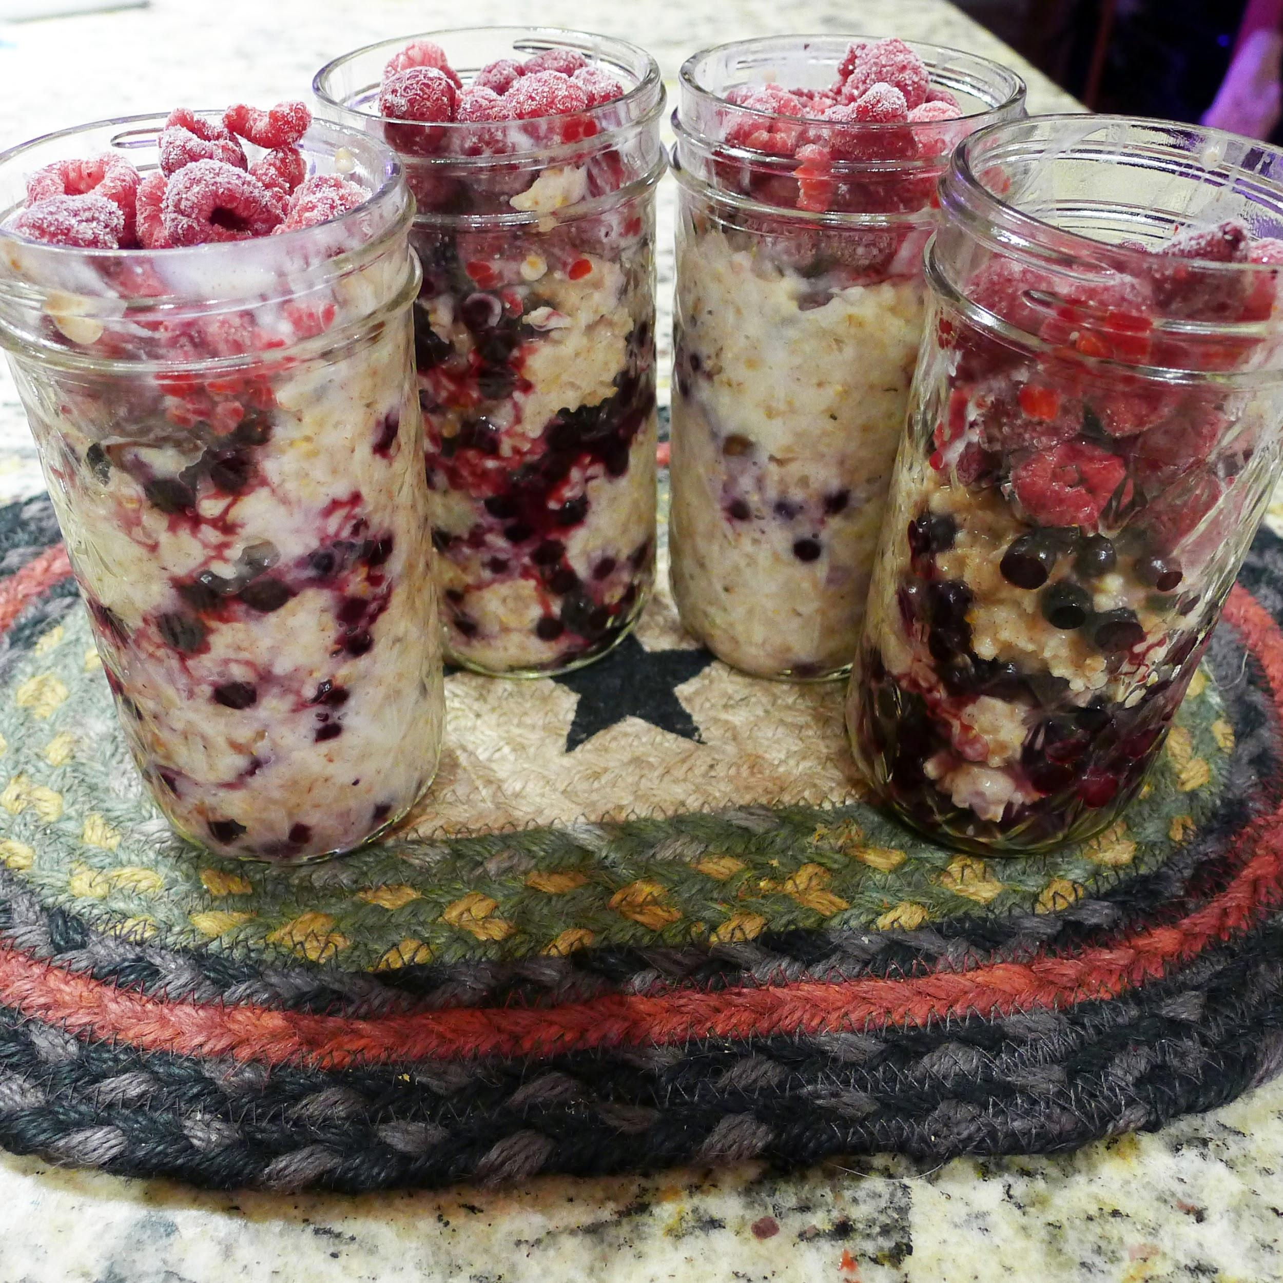
Once the 20 minutes have passed, turn the vent to the "venting" position to release any remaining pressure. Carefully remove the lid and stir the oats to incorporate any water that has risen to the top. They should be nice and thick, with a porridge-like texture.
Serve warm with cinnamon, fruit and a splash of non-dairy milk, if desired. Leftover oats can be stored in individual containers in the fridge for up to a week, for a fast breakfast on the go.
Note: I wait until this is completely cool and then add frozen berries and store for the week.

