Simply Sweet Potato Stew

Recipe
Jeanne Schumacher

www.simplyplantbased.net

Servings: 6-8
Prep time: 15 min.
Cook time: 30 minutes

Ingredients
- ½ cup dried green lentils
- ¾ cup dried red lentils
- 4 garlic cloves, peeled
- 6 ounce can tomato paste
- 1.5 tbsp Berbere spice (on Amazon – also google recipe)
- 1 box low sodium veggie broth
- 1 cup water
- 2 medijool dates, pitted
- 3 medium to large sweet potatoes (1/2’ cubed)
- 2 tbsp fresh ginger (grated)
- 2 tbsp fresh turmeric (grated)
- 1-15 ounce bag frozen spinach

Procedure
In a high speed blender mix together the water and dates. Blend until smooth. Add to blender tomato paste, garlic cloves, Berber spice, ginger, and turmeric. Lightly blend together. Add to the instant pot all the ingredients and stir. Use manual setting for 30 minutes. Make sure vent is in sealing position. The IP will turn on by itself.

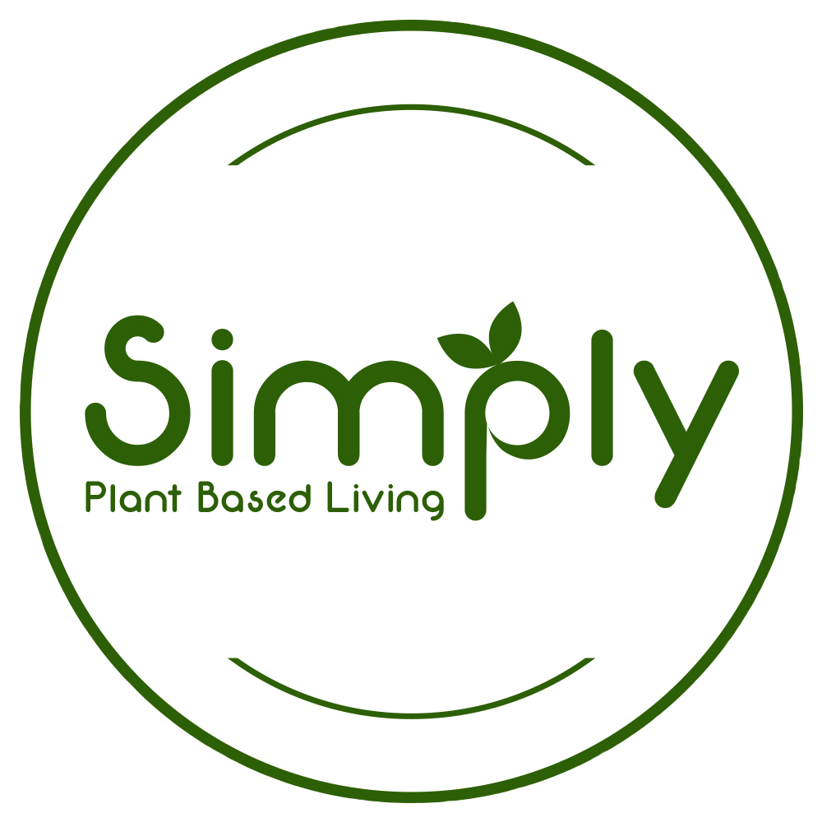
When the cooking is done, allow the lid and vent to stay closed for at least 10 minutes (to let the pressure naturally release). After the pressure has released, be sure to turn the lever on the lid to the "venting" position to release any remaining steam. Remove the lid and stir. Serve over a grain for a heartier meal.

Notes:
- If you do not have an IP, place all ingredients in a pot and simmer until the green lentils are tender.
- Recommend Field Day Low Sodium Veggie Broth!
- Eat over a grain or rice to make this a full meal!

