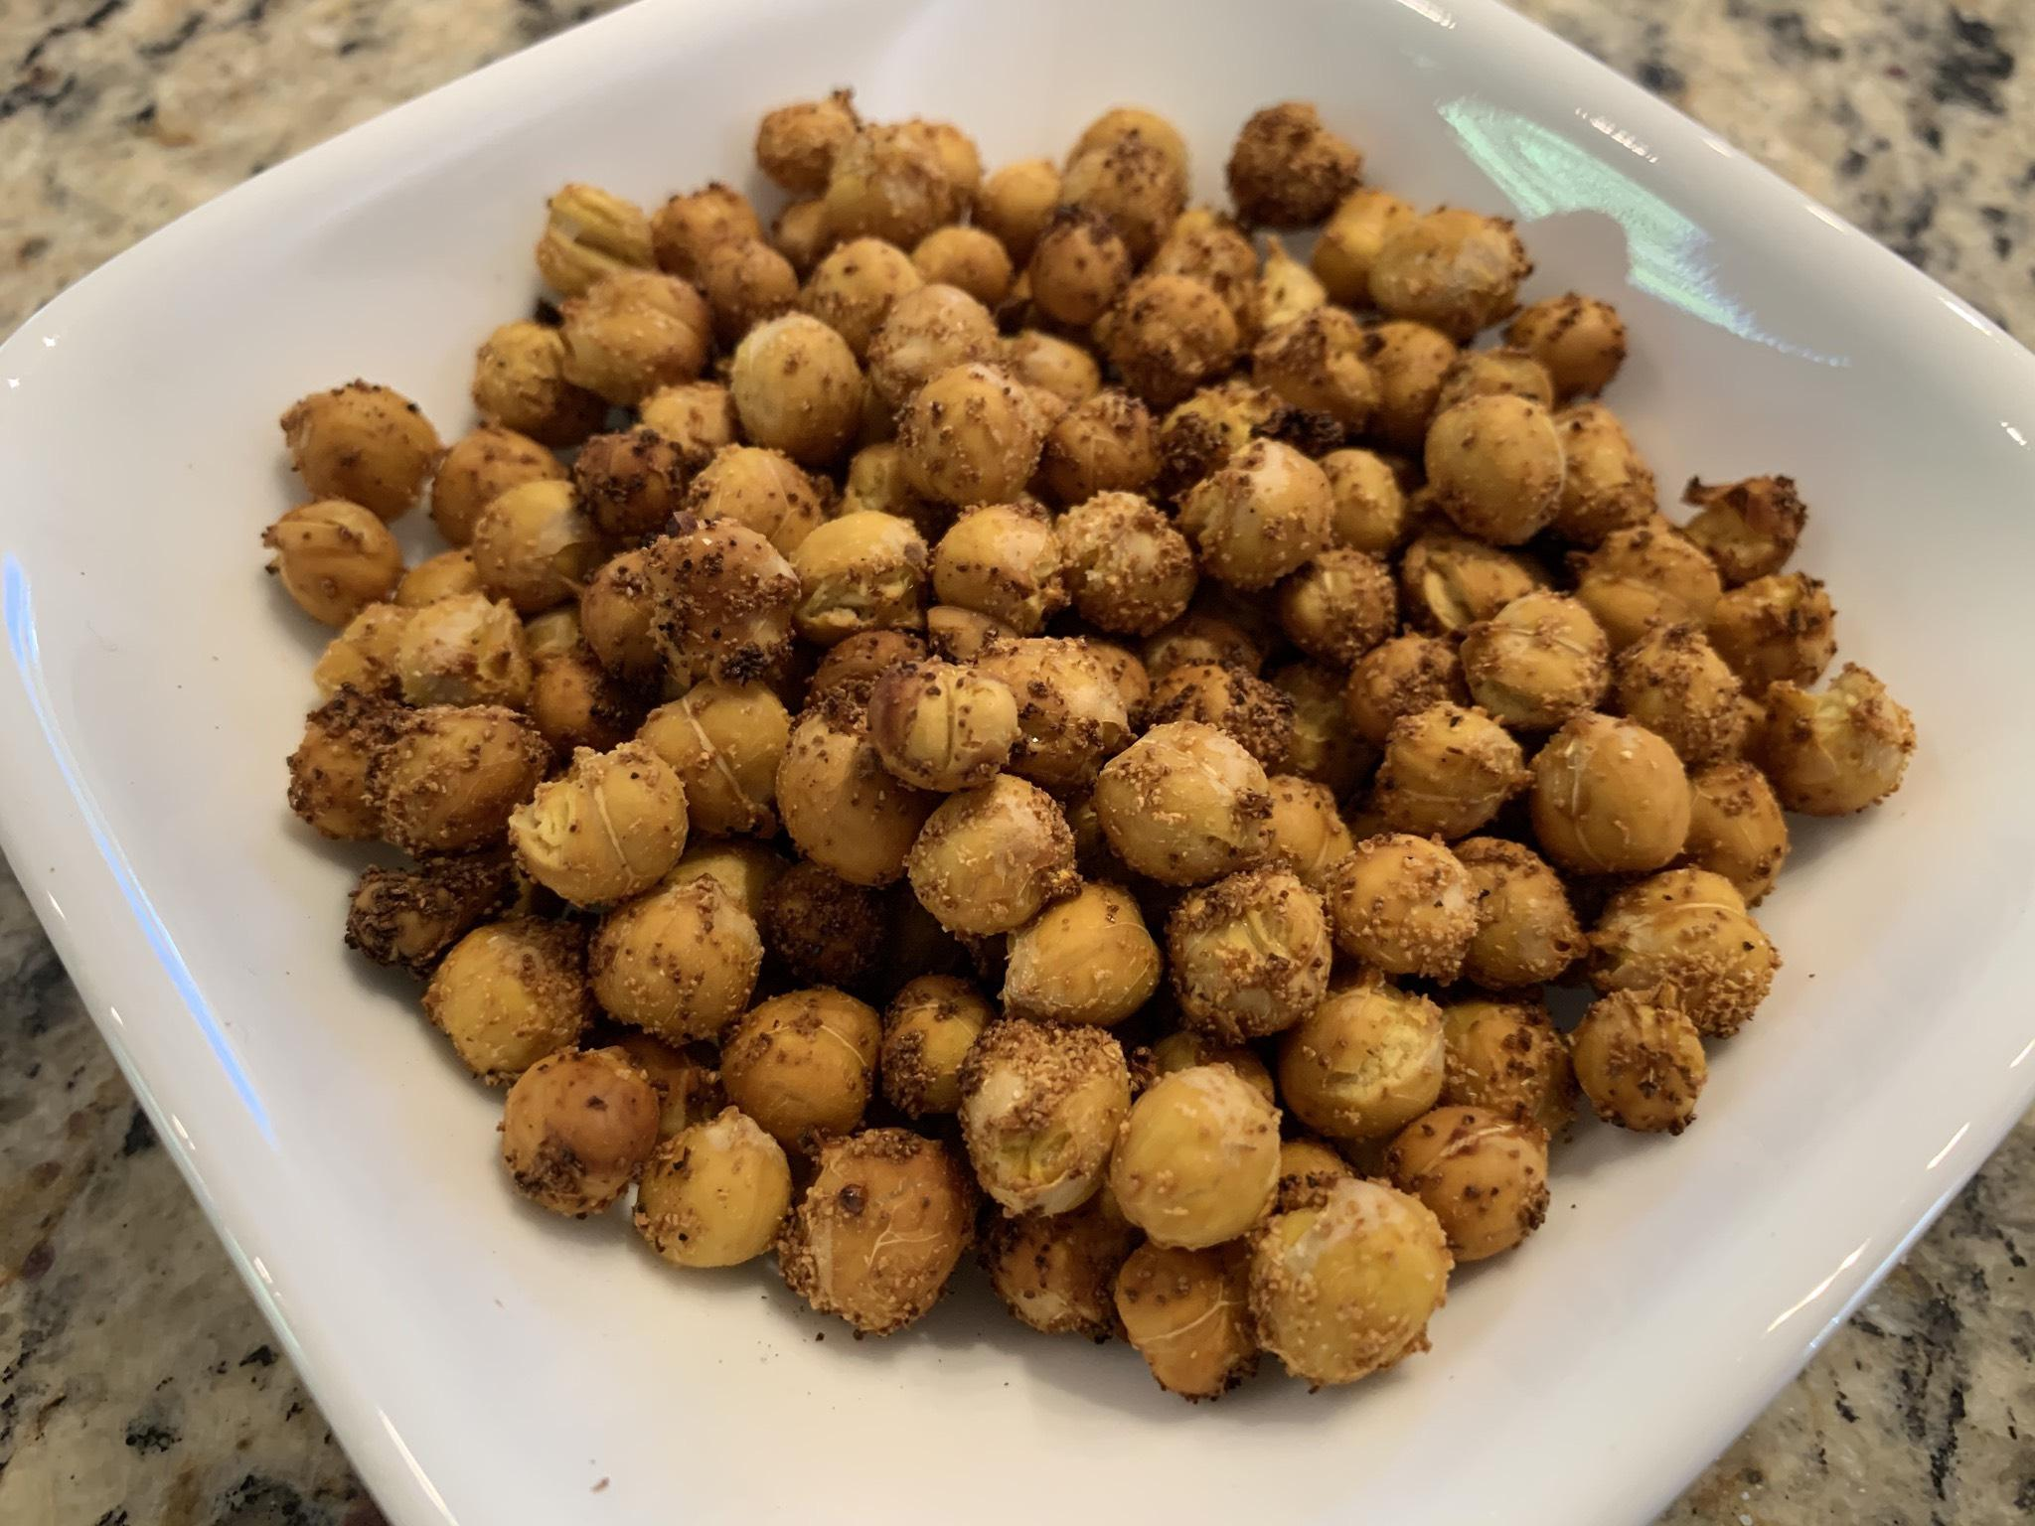
Simply Crunchy Chickpea

By Jeanne Schumacher
www.SimplyPlantBased.net

Where have these been all my life? Make a lot. These will get eaten very quickly.

If any are left, you can toss on a salad for additional crunchiness.

Ingredients
- Vast amount of pre-cooked chickpeas or garbanzo beans, drained
- Onion powder
- Garlic powder

Directions
- Place in an air fryer and cook at 400 degrees F for 12-15 minutes.
- If cooking a lot of them, stop ½ way through and stir, then continue heating. May have to do it more than once.

Notes:
- To take this to the next level, add Berbere spice.
- This recipe works for any of your favorite spices. Be bold. Be brave and condiment well!
- Always keep garbanzo beans in the fridge. You can make hummus very easily.

