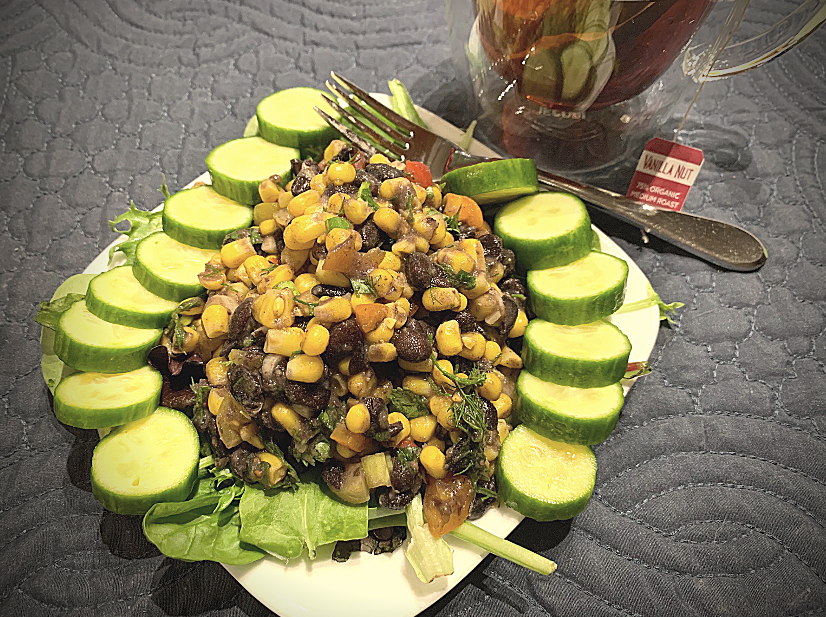
Simply Corn and Black Bean Salad

by Jeanne Schumacher

www.SimplyPlantBased.net

prep time: 15 minutes

Great summer salad. Easy to make.
Travels well. Better yet, it requires no heat!

Ingredients:
- 1 package frozen corn
- 2-15 ounce cans (no salt) black beans, rinsed and drained
- 1 bunch green onions
- 1 small bunch cilantro , chopped
- 1 small bunch dill, chopped
- 4 cloves minced garlic
- 1 cup cherry tomatoes, chopped
- 1/4 cup chopped cilantro
- juice of 1 large lemon
- zest of 1 lemon
- Black pepper to taste
- Veracha Sauce to taste (optional - this will add a kick - see notes)

Instructions:
Combine in a bowl and mix well. Let sit 1 hour before serving.

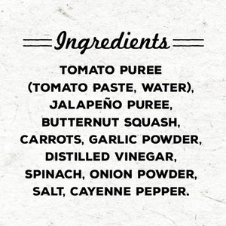
Notes:
- Sometimes I don't have 2 cans of black beans on hand. So I will use another bean or chickpea.
- My go to for seasoning is Berbere. To add a nice flavor and kick up the spice...add 1-2 teaspoons in place of veracha sauce.
- Serve over a large bed of greens or grains.
- Veracha sauce is from True Made Foods and is a vegetable sriracha. Check out the ingredients!

