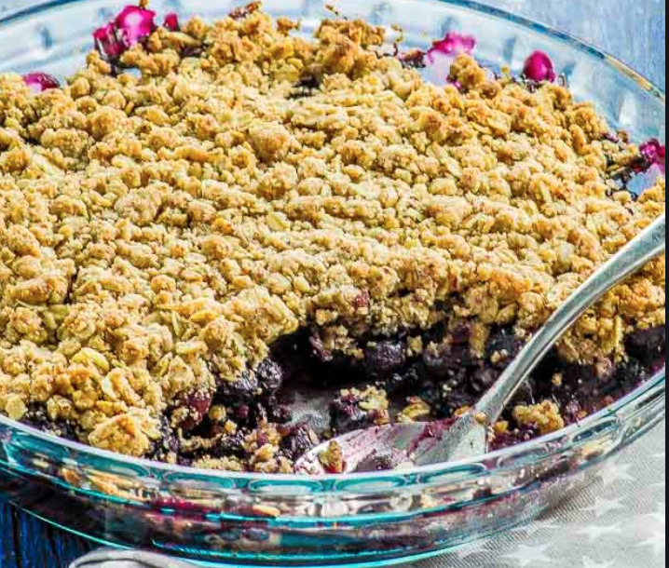
Simply Blueberry Cobbler

By Jeanne Schumacher
www.SimplyPlantBased.net

Serves: 3-4

This vegan blueberry crumble is like a huge scoop of summer on a plate! Serve with nice cream to take this to Jedi level!

Ingredients
- 1 banana, diced
- 1 cup frozen blueberries
- 1 cup frozen blackberries
- 1 teaspoon vanilla
- ¼ cup water
- 2 tablespoon arrowroot
- 1 tablespoon pumpkin pie spice

Topping:
- 2 tablespoons chopped raw almonds
- 2 tablespoons unsweetened, shredded coconut
- 3/4 cup old fashioned rolled oats

Directions:
- Wisk together the water and arrowroot and add to a large saucepan. Combine in the saucepan the banana, berries, vanilla and pumpkin pie spice. Gentle heat until it thickens.
- In another pan, toast the oats, almonds and coconut. When toasted, use to top the berry banana mixture. Serve warm.

